# Cybersecurity Project

# 28/04/2024

# Monthly Project report

**For further information:**

Jarna Salonen

Shehreen Haider

Nick Woolcock

# Guide

## Monthly Project tracking meetings

Refer to Gant Chart and Trello

Meeting 15+5 minutes

* referring to MS Project Gant Chart and Trello board
* Monitor progress and track:
  + Procurement – Pending MS Project
  + Project progress to timelines – We are on track. Setting our baseline project.
  + Identify and document variations – No variation at this stage.
  + Monitor risks – update risk register – Not having access to MS project.
  + Quality (Testing) – N/A at this stage
  + Budget progress relative to projections – Developing baseline and scoping within budget.
  + Critical path analysis – Prototype, production, documentation, presentation.
  + Sprint Retrospective – Full capacity of resources, set up teams group.
* Meeting minutes – Taking notes on Trello
* Documentation – Monthly production report for submission
* Retrospective (5 Mins)

## Procurement progress and tracking

* Initiation has been completed, Trello board has been set up for sprints and completed task. Gantt chart will be completed as required.

## Project progress to timelines

* Initiation completed.
* Complete GANTT Chart is attached.

## Identify and document variations

* List of variations and impact of each (impact cost + time) – To be determined

**Monitor risks – update risk register**

| Id | Description of Risk | Impact or consequence | Likelihood/ Seriousness | Grade | Change | Mitigation Actions  (Preventative or Contingency) | Individual/Group Responsible for Mitigation Action | Timeline for Mitigation Action |
| --- | --- | --- | --- | --- | --- | --- | --- | --- |
| 1 | MS Project | Not able to share documents with the team members | High | 5 | none | Classroom use |  |  |
| 2 |  |  |  |  |  |  |  |  |

**Quality - Verify Prototype is meeting project technical requirements**

* **Criteria of project outputs**  
  GANTT Chart established with baseline and cost projections.
* **Testing procedures used so far to verify quality of outcomes – Are we meeting the project requirements?**Not applicable at this stage.
* **Paragraph summary**  
  At this stage we haven’t done any testing

**Budget progress relative to projection:**

* Project currently running to budget and baseline projections.

**

* Set-up and Interconnect Networking Infrastructure is now critical, but will completed this week. All other tasks are currently on track.

**Sprint retrospective**

* **What went well**  
  We were able to get MS Teams operational. It was beneficial for the team to use outside of class hours.  
  We were able to work well together as a team, and our stand-ups were effective.
* **What needs Improvement**Better communication between the team on technical and project tasks.  
  Full team is unable to access MS Projects.
* **Actions**Utilise MS projects during class times.  
  Work with Excel spreadsheeets.
* **Summary**  
  Overall we were able to utilise the Project Management tools and ceremonies effectively. This enabled us to have a transparent communication and updates during the week. Some team members were able to start on the set-up and configuration tasks.

### Activities:

1. Update Project documentation (monthly report) to include items discussed in progress report
2. Revise Gant chart
3. Update risk register
4. Monthly project tracking meeting minutes documented
5. Sprint retrospective

### References:

Critical path - <https://support.microsoft.com/en-us/office/show-the-critical-path-of-your-project-in-project-desktop-ad6e3b08-7748-4231-afc4-a2046207fd86>

MS Project cost totals - <https://support.microsoft.com/en-us/office/view-project-cost-totals-0d3a2451-fb1e-4ba0-826e-20ee3b3d60cc>

Baseline – MSProject - <https://support.microsoft.com/en-us/office/create-or-update-a-baseline-or-an-interim-plan-in-project-desktop-7e775482-ac84-4f4a-bbd0-592f9ac91953>

**MS project reports**

Project > project Information > Statistics

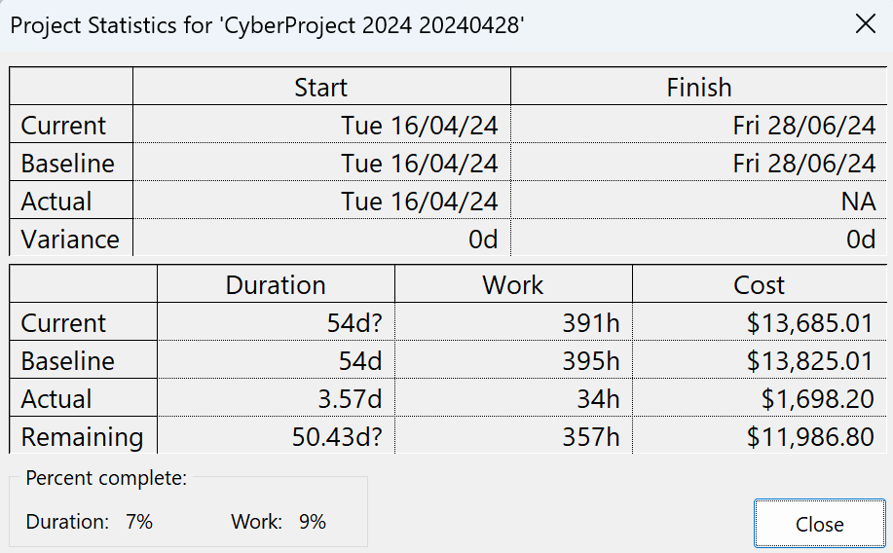

Report > dashboard > Project Overview

Report > costs > task cost overview

Report > In progress > Milestone report

Report > resources > resource Overview

**Key to Risk Rating Symbols used:**

|  |  |  |  |
| --- | --- | --- | --- |
| Rating for Likelihood and Seriousness for each risk | | | |
| L | Rated as Low | E | Rated as Extreme (Used for Seriousness only) |
| M | Rated as Medium | NA | Not Assessed |
| H | Rated as High |  |  |

|  |  |  |  |  |  |
| --- | --- | --- | --- | --- | --- |
| Grade: Combined effect of Likelihood/Seriousness | | | | | |
|  | Seriousness | | | | |
| Likelihood |  | low | medium | high | EXTREME |
| low | N | D | C | A |
| medium | D | C | B | A |
| high | C | B | A | A |

|  |  |
| --- | --- |
| Recommended actions for grades of risk | |
| Grade | Risk mitigation actions |
| A | Mitigation actions to reduce the likelihood and seriousness to be identified and implemented as soon as the project commences. |
| B | Mitigation actions to reduce the likelihood and seriousness to be identified and appropriate actions implemented during project execution. |
| C | Mitigation actions to reduce the likelihood and seriousness to be identified and costed for possible action if funds permit. |
| D | To be noted - no action is needed unless grading increases over time. |
| N | To be noted - no action is needed unless grading increases over time. |

|  |  |  |  |
| --- | --- | --- | --- |
| Change to Grade since last assessment | | | |
| NEW | New risk | ↓ | Grading decreased |
| — | No change to Grade | ↑ | Grading increased |